Draft Conceptual Model Overview II
Paul Ross
College of Doctoral Studies, Grand Canyon University
PSY-969E: Research Continuation II
Dr. Maul
September 5, 2025.

Graphical Conceptual Model Schema Overview
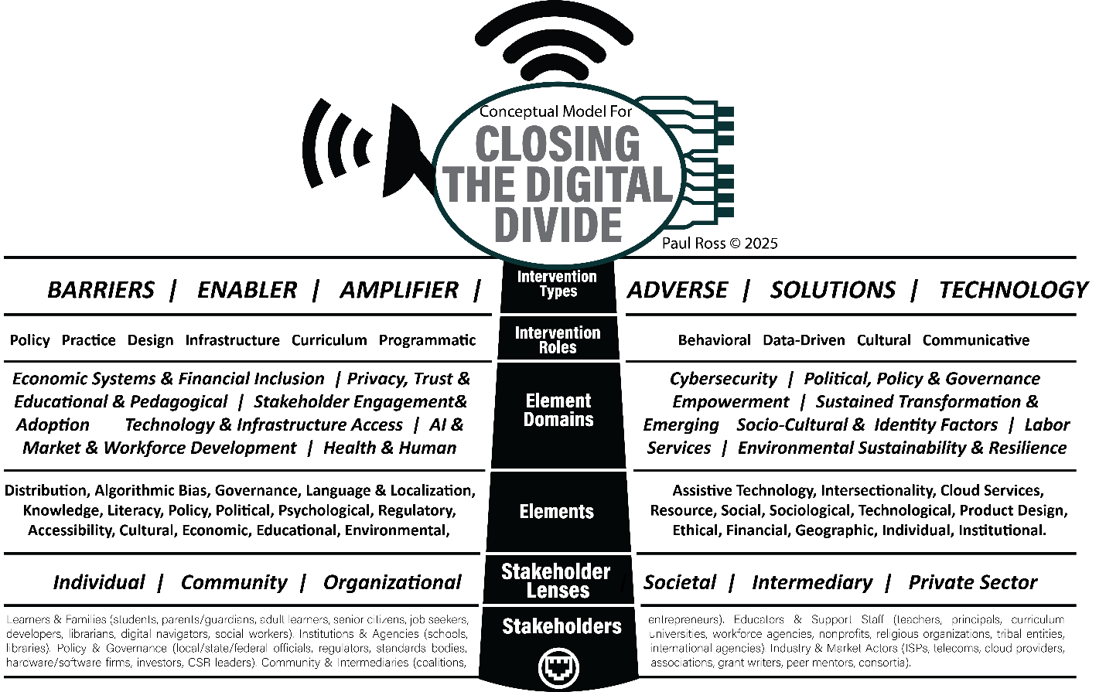
9-5-2025 Current Model
Model Version 12

Model Version 11
Brief One-Page Overview
Objective
Closing the Digital Divide
Stakeholders
From which there are many.
Stakeholder Perspective Lenses
Individual, Community, Organizational, Societal, Intermediary, and Private Sector.
Domains
Economic Systems & Financial Inclusion
Privacy, Trust & Cybersecurity
Political, Policy & Governance
Educational & Pedagogical Systems
Stakeholder Engagement & Empowerment
Sustainable Transformation and Adoption
Technology & Infrastructure Access
AI & Emerging Technologies
Socio-Cultural & Identity Factors
Labor Market & Workforce Development
Health & Human Services
Environmental Sustainability & Resilience
Elements
Accessibility, Cultural, Economic, Educational, Environmental, Ethical, Financial, Geographic, Individual, Institutional, Knowledge, Literacy, Policy, Political, Psychological, Regulatory, Resource, Social, Sociological, Technological, Product Design, Distribution, Algorithmic Bias, Platforms, Language & Localization, Assistive Technology, Intersectionality, and Cloud Services.
Intervention Roles
Barrier, Enabler, Amplifier, Adverse Impact, Solution, and Technology.
Intervention Types
Policy, Practice, Design, Infrastructure, Curriculum, Programmatic,
Behavioral, Data-Driven, Cultural, and Communicative.

Model Overview
Stakeholder Summary
Each stakeholder group contains many individual stakeholders. Those listed are a sample.

- Learners & Families (students, parents/guardians, adult learners, senior citizens, job seekers, entrepreneurs).
- Educators & Support Staff (teachers, principals, curriculum developers, librarians, digital navigators, social workers).
- Institutions & Agencies (schools, universities, workforce agencies, nonprofits, religious organizations, tribal entities, libraries).
- Policy & Governance (local/state/federal officials, regulators, standards bodies, international agencies).
- Industry & Market Actors (ISPs, telecoms, cloud providers, hardware/software firms, investors, CSR leaders).
- Community & Intermediaries (coalitions, associations, grant writers, peer mentors, consortia).

Stakeholder Lenses
Each lens provides a distinct perspective.

- Individual = personal access, skills, identity factors.
- Community = peer networks, cultural values, grassroots support.
- Organizational = institutional practices, budgets, IT infrastructure.
- Societal = laws, regulations, systemic norms.
- Intermediary = nonprofits, consortia, advocacy coalitions bridging actors.
- Private Sector = market-driven innovation, CSR initiatives, investment flows.
This ensures that every stakeholder can be examined through multiple “lenses” without overlap.

Elements
There are multiple elements which need to be considered when examining the digital divide. The individual elements can roll-up into overarching categories.
- Distribution - The processes and mechanisms by which digital resources (devices, connectivity, infrastructure) are allocated and delivered to users. In the divide, inequitable distribution leads to gaps in access.
- Algorithmic Bias - Systematic errors embedded in algorithms and automated systems that disproportionately disadvantage certain groups, reinforcing inequities in digital access and opportunities.
- Governance - The structures, rules, and oversight mechanisms that guide how digital infrastructure, platforms, and programs are managed at organizational, local, national, or global levels.
- Language & Localization - The adaptation of technology, digital content, and services to users’ linguistic and cultural contexts to ensure usability, comprehension, and inclusivity.
- Assistive Technology - Tools and devices (hardware or software) designed to support individuals with disabilities or special needs in accessing digital environments.
- Intersectionality - The way overlapping identities (race, gender, class, disability, etc.) shape unequal experiences of digital access and participation.
- Cloud Services - On-demand computing services (data storage, processing, applications) delivered via the internet, critical for modern infrastructure but potentially widening divides when access or affordability is unequal.
- Knowledge - The depth of understanding, information, and awareness required to effectively use digital tools — beyond technical literacy, it includes critical and applied competencies.
- Literacy - The foundational digital skills needed to navigate, evaluate, and create information online. It includes both technical fluency and critical thinking in digital environments.
- Policy - Formal statements of intent, rules, or plans enacted by institutions or governments to regulate digital access, infrastructure, and equity.
- Political - The dynamics of power, decision-making, and influence that shape digital equity, often through lobbying, partisanship, or agenda-setting beyond formal policy.
- Psychological - Cognitive and emotional factors (motivation, fear, trust, self-efficacy) that influence whether individuals engage with digital technologies.
- Regulatory - Legal frameworks and enforcement mechanisms (laws, compliance requirements) that govern digital access, safety, and equity.
- Resource - The tangible and intangible assets (funding, personnel, equipment, time) required to support equitable digital inclusion.
- Social - The networks, relationships, and social dynamics that shape how digital technologies are accessed and used within communities.
- Sociological - The broader structural and societal patterns (inequality, institutions, demographics) that affect digital access and participation.
- Technological - The actual hardware, software, and networks that make digital connectivity possible — including both legacy and emerging systems.
- Product Design - The way digital devices, apps, or platforms are conceived and built, including considerations of usability, accessibility, and inclusivity.
- Accessibility - The degree to which digital technologies and content are usable by people of all abilities, including those with disabilities, limited literacy, or language barriers.
- Cultural - Shared values, traditions, and practices that influence how communities perceive and adopt digital tools.
- Economic - Financial and structural conditions that determine whether individuals or communities can afford and sustain access to digital resources.
- Educational - The systems, curricula, and pedagogical practices that shape digital learning opportunities and competencies.
- Environmental - The ecological and physical contexts (infrastructure resilience, sustainability, natural disasters) that influence digital access and reliability.
- Ethical - Moral considerations in digital practices, including equity, fairness, rights, and the responsible design and deployment of technologies.
- Financial - The specific monetary instruments, costs, and funding flows that affect access (e.g., affordability of plans, subsidies, capital investment).
- Geographic - The spatial dimensions of digital access, including urban/rural divides, terrain challenges, and infrastructural reach.
- Individual - Personal characteristics (age, ability, income, identity, mindset) that shape how someone experiences the digital divide.
- Institutional - The norms, practices, and structures of organizations (schools, governments, companies) that shape digital access and literacy opportunities.
Element Domains
Your domains are already broad and thematic, but they overlap (e.g., Political, Policy & Governance vs. Privacy, Trust & Cybersecurity). The individual domains can be further grouped however for full analysis the extended list of domains is included.
- Infrastructure & Technology: Technology & Infrastructure Access; AI & Emerging
- Economic & Market Systems: Economic Systems & Financial Inclusion; Labor Market & Workforce Development
- Governance & Trust: Political, Policy & Governance; Privacy, Trust & Cybersecurity
- Education & Capacity: Educational & Pedagogical; Stakeholder Engagement & Empowerment
- Equity & Identity: Socio-Cultural & Identity Factors; Health & Human Services
- Sustainability & Resilience: Environmental Sustainability & Sustained Transformation
Extended Element Domain List
- Economic Systems & Financial Inclusion
The structures, markets, and mechanisms that determine how individuals and communities afford and sustain digital access. Includes affordability of services, subsidies, inclusive financing, and economic participation through digital economies.
- Privacy, Trust & Cybersecurity
The protections, safeguards, and perceptions surrounding digital safety, data privacy, and system integrity. Trust in digital systems is critical for adoption, while breaches or insecurities deepen the divide.
- Political, Policy & Governance
The institutions, rules, and power structures that create the legal and regulatory frameworks for digital access. Covers government policy, regulatory agencies, political agendas, and governance practices that influence equity.
- Educational & Pedagogical
The systems of learning, teaching, and instructional design that shape how digital literacy and skills are developed. Includes formal curricula, teacher training, and pedagogy that embeds equitable technology use.
- Stakeholder Engagement & Empowerment
The processes of involving individuals, families, and communities in shaping digital initiatives. Empowerment ensures interventions are trusted, co-created, and responsive to actual community needs.
- Sustained Transformation & Adoption
The long-term integration of digital systems into everyday life. Goes beyond initial adoption to include cultural shifts, funding stability, policy continuity, and intergenerational change.
- Technology & Infrastructure Access
The physical and technical backbone of the digital ecosystem, including networks, broadband, hardware, and platforms. Focused on availability, quality, and reliability of the infrastructure that underpins digital access.
- AI & Emerging
The disruptive and evolving technologies (artificial intelligence, IoT, AR/VR, blockchain, etc.) that present both new opportunities and risks for digital equity. Ensures emerging innovations are accessible and inclusive.
- Socio-Cultural & Identity Factors
The cultural, social, and identity-based influences (race, language, gender, class, disability, traditions) that shape how individuals perceive, trust, and use digital technologies.
- Labor Market & Workforce Development
The systems that connect digital skills to employment opportunities. Includes job training, reskilling programs, credentialing, and preparation for technology-driven labor markets.
- Health & Human Services
The role of digital access in delivering healthcare, social support, and emergency services. Telehealth, online benefits, and digital case management fall here as critical equity factors.
- Environmental Sustainability & Resilience
The ecological and infrastructural considerations for ensuring digital systems are sustainable and resilient. Includes energy demands, climate impacts, and system robustness during crises (e.g., storms, wildfires).
Intervention Roles
The functions through which stakeholders influence outcomes to Close the Digital Divide such as infrastructure deployment, policy-making, program delivery, cultural engagement, or data use.

- Infrastructure & Design: Infrastructure, Design
- Policy & Governance: Policy, Regulatory/Data-Driven
- Programs & Practice: Programmatic, Curriculum, Behavioral
- Culture & Communication: Cultural, Communicative
- Accountability & Evidence: Data-Driven (moved here as a cross-cutting role)
Intervention Types
The effect outcomes have on the digital divide, classified as barriers, enablers, amplifiers, solutions, adverse outcomes, or technology contexts.

- Barriers: Structural or systemic obstacles.
- Enablers: Factors that create access or opportunity.
- Amplifiers: Forces that magnify or accelerate impact.
- Solutions: Concrete interventions classified as solutions that directly address needs.
- Adverse: Negative or unintended consequences.
- Technology: Treated in multiple ways, not just a solution, but depending on the context, can be a barrier, an enabler, an amplifier, or an adverse depending on use.

APPLICATION SYNTHESIS OF THE MODEL
To test the application of the model, it has been applied to five scenarios. A further element has been added to provide additional context to identify the data sources that would be needed to consider the scenario.
1. Hotspot Program (School District)
In the school district hotspot program, the barrier is not connectivity itself but affordability and equitable access to learning outside of school. The school by distributing hotspots, acts as an infrastructure provider enabling connectivity, while teachers and families amplify the intervention through curriculum redesign and digital use at home. The program succeeds when privacy safeguards and communication are handled well, ensuring it functions as an enabler rather than an adverse outcome.
Key Data Sources:
- School District IT & Inventory Records - number of hotspots distributed, device type, costs, loss rates, with breakdowns by grade and classroom.
- Student Connectivity & Usage Logs - login data, bandwidth consumption, participation in digital assignments, use of video, types of applications used connected to the curriculum.
- Learning Management Systems (LMS) - student logins, engagement metrics, assignment submission rates, and rates attendance.
- Surveys of Students, Parents, Teachers - affordability, end user satisfaction, literacy and knowledge, and privacy concerns.
- FERPA & CIPA Compliance Reports - data privacy, filtering alerts, categories of filtering, and online safety monitoring.
- Community ISP Coverage Maps - service availability from local metrics and FCC data sources, and affordability comparisons across types of access and service providers.
2. MDU Upgrade (Apartment Complex)
For a multi-dwelling unit (MDU) upgrade, the intervention is reliant on infrastructure, with fiber and smart-home installations serving as the core enabler. Property owners often act as barriers if costs, incentives, or investments are misaligned, while ISPs provide the solution by delivering upgraded infrastructure. Success depends on policy alignment and cultural outreach to ensure residents adopt and trust the upgrades deployed, while training programs and government oversight amplify the long-term impact if there are subsidies and connected policies impacting service implementation and delivery. Without these supports, the system risks adverse outcomes like unfair pricing or unreliable performance.
Key Data Sources:
- Property Owner / Management Records - building infrastructure condition, investment costs, upgrade schedules, previous infrastructure diagrams, and support/maintenance records.
- ISP Service Availability & Pricing Data - service tiers, competition levels, pre/post-upgrade pricing, reported usage metrics.
- Tenant Surveys - affordability, trust, social media postings, service ratings and comments, willingness to adopt new services, and cultural and ethnicity groupings.
- FCC Broadband Data Collection (BDC) / Form 477 - official service availability, coverage and reported speeds, from government databases and end user bandwidth testing services.
- HUD / Local Housing Authority Reports - subsidies, policy incentives, regulatory alignment, equity and telecommunication plans.
- Smart Home Device Telemetry (opt-in) - adoption, reliability, acceptance, and usage patterns for each type of device.
3. Rural Community
In the rural community scenario, the dominant barrier is geographic isolation and the high cost of last-mile access, and no options for middle-mile access. Federal and state funding shifts these challenges into enablers by underwriting fiber and tower infrastructure, while ISPs transform them into solutions. Schools and libraries act as amplifiers by embedding digital literacy and serving as trusted anchor institutions, while local governments amplify adoption through data-driven decision making. If governance fails or affordability programs are absent, the system, and installed infrastructure risks being underutilized even when the infrastructure investment is available for example through the BEAD program.
Key Data Sources:
- FCC Broadband Maps & BEAD Program Data - served/unserved designations, funding allocations, and proposals submitted.
- Middle-Mile & Last-Mile Infrastructure Reports - NTIA, USDA, FCC, local and state broadband offices.
- Local Government Planning Records - zoning, permitting, tower locations, historical permits, and right-of-way permits.
- School & Library Connectivity Reports - Erate and USAC historical data, previously funded services, and institutional access levels.
- Adoption & Affordability Surveys - household take-up rates, digital literacy gaps, and local education attainment.
- Crowdsourced Speed Test Data (e.g., Ookla, M-Lab) - end-user reported bandwidth reports for the validation of coverage.
4. Extreme Remote Residence
For a single extreme remote residence, fiber and tower installation is infeasible, making satellite broadband the only viable solution. The ISP is the solution provider, but affordability is a significant barrier without subsidies even when operating remote and access is possible. Local government and federal agencies act as enablers when they allocate resources through universal service funds and lifeline access, while telehealth programs raise and amplify the impact by reducing isolation and ensuring essential services are reachable. The sustainability of this scenario rests on policy efficiency. The question remains whether serving of a single household can be justified as an equity priority without becoming an adverse cost burden.
Key Data Sources:
- Satellite ISP Coverage Maps (Starlink, HughesNet, Viasat) - service availability, coverage and latency profiles.
- FCC Universal Service Fund (USF) and Lifeline Data - subsidy eligibility and uptake, and previously deployed services.
- Household Affordability Surveys - actual costs vs. resident income as a percentage of spend against technology adoption.
- Telehealth Utilization Records - access to remote health services, and appointment frequency.
- Geospatial Mapping (GIS) - terrain, remoteness, feasibility of alternatives, point-to-point and point-to-multipoint feasibility studies.
- Cost-Benefit Analyses from Policy Reports - long-term sustainability of subsidies or assessments for deploying physical infrastructure for edge cases due to accessibility or remoteness.
5. Urban Underserved Neighborhood (Phoenix)
In the Phoenix neighborhood, the FCC classifies the area as “served,” yet affordability and mistrust remain the central barriers. Infrastructure exists, but residents face economic and psychological barriers that render service inaccessible. ISPs can provide solutions by designing prepaid or low-cost plans, while community organizations act as enablers by bridging trust gaps with culturally relevant outreach. Schools and libraries amplify adoption through training, education, and awareness but government subsidy programs risk becoming adverse if they are seen as complex, deceptive, or disconnected from community needs. The intervention’s success depends less on infrastructure and more on rebuilding trust and lowering financial barriers.
Key Data Sources:
- FCC Broadband Service Data (Form 477, BDC) - classification as “served,” and availability across ISPs.
- ISP Pricing Plans - prepaid, low-cost options, hidden fees, contractual requirements, time to complete paperwork, and portability between locations and devices.
- Community Surveys & Focus Groups - perceptions of affordability, trust in government programs, commercial systems used, privacy and data security, subsidy schemes, and program plans.
- Adoption Data from ACP/EBB (Affordable Connectivity Program / Emergency Broadband Benefit) - enrollment and rejection rates, continuation rates for people who were on ACP prior to withdrawal, and their current status.
- Anchor Institution Reports (Schools/Libraries) - participation in training, device loans, type of bandwidth installed, bandwidth used day-to-day, and digital literacy programs.
- Local Nonprofit Program Evaluations - cultural outreach success/failure, case studies of trust building, community outreach programs, and level of interest in literacy and technology usage.
Application Synthesis Table
Scenario | Primary Barrier(s) | Primary Enabler(s) | Primary Solution(s) | Primary Amplifier(s) | Potential Adverse(s)
Hotspot Program (School District) | Affordability if unsubsidized; Privacy risks | Hotspot distribution; Programmatic rollout | Hotspots as access technology | Teachers redesigning curriculum; Family training | Weak privacy protections; Miscommunication
MDU Upgrade (Apartment Complex) | Property owner resistance; Cost of upgrades | Subsidies, bulk service contracts, and Accessible design | ISP infrastructure buildout (fiber/Wi-Fi) | Community training; Government oversight | Unfair pricing; Inadequate maintenance
Rural Community (Fiber + Towers) | Geographic isolation; Affordability without subsidies | Federal/state funding; Fiber and tower infrastructure | Fiber-to-the-home; multi-tower wireless network | Schools/libraries as anchor institutions | Weak governance â†’ underutilized networks
Extreme Remote Residence | Fiber/tower infeasible; High satellite cost | Satellite broadband with subsidy | Satellite broadband service | Telehealth access reduces isolation | Unsustainable subsidy; Satellite unreliability
Urban Underserved Neighborhood (Phoenix) | Affordability; Mistrust of government programs | Community organizations; Affordable plan design | Low-cost ISP plans (prepaid, no-contract) | Schools/libraries embedding digital equity | Distrust flips policy into an adverse outcome

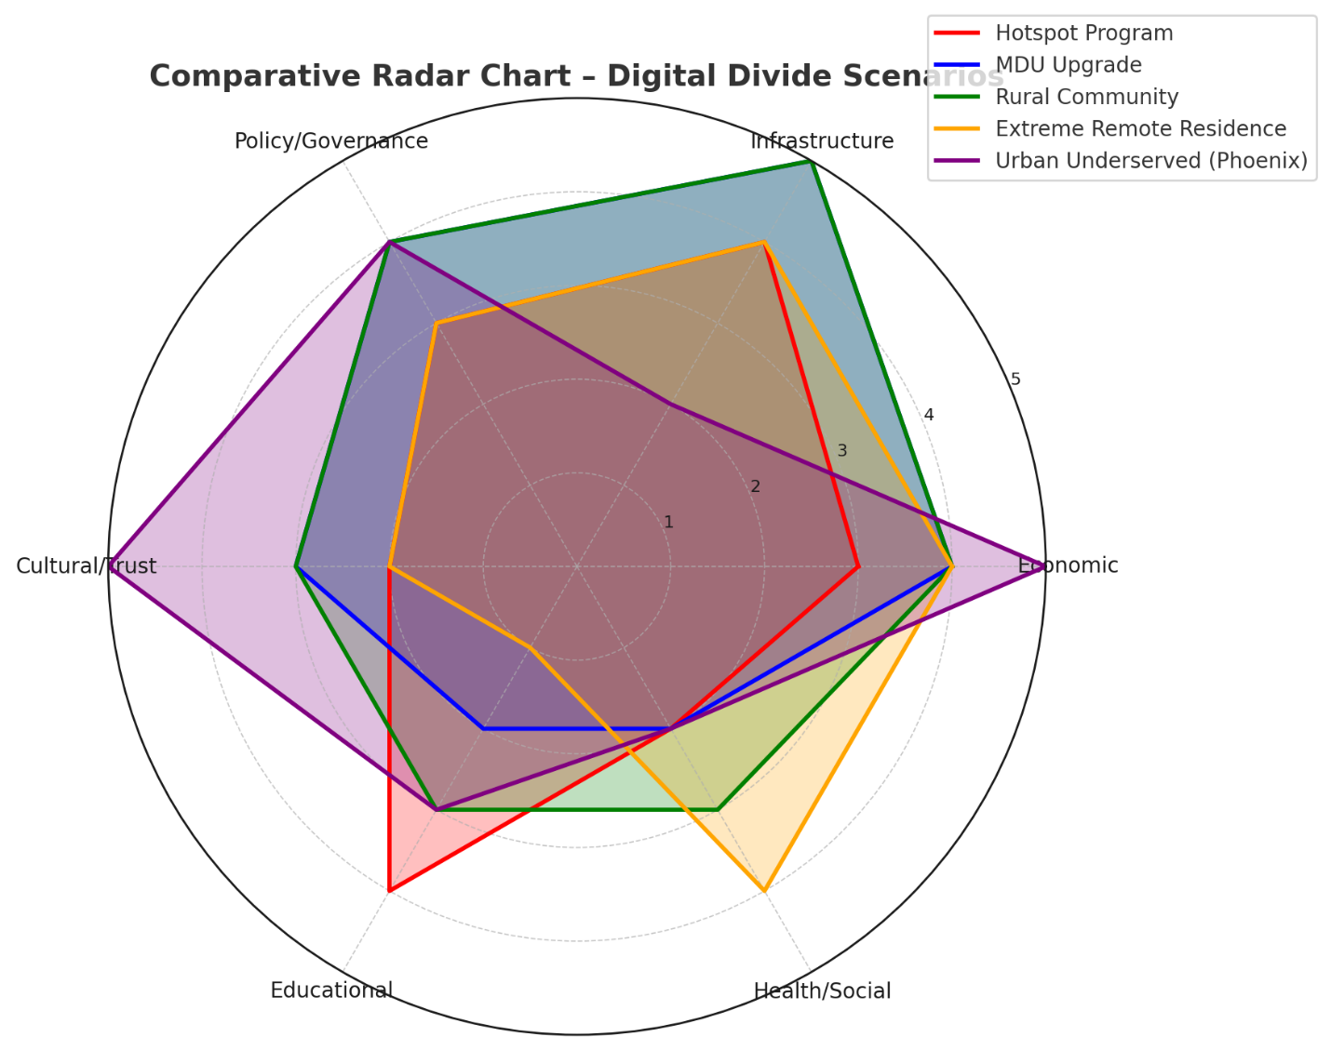

Visualization Insights
- Hotspot Program - balances between infrastructure and educational amplifiers.
- MDU Upgrade - dominated by infrastructure and economic investment, with strong policy alignment needed.
- Rural Community - heavily infrastructure-driven but equally reliant on economic and governance domains.
- Extreme Remote Residence - strong in economic + health/social (telehealth), with infrastructure limited to satellite.
- Urban Underserved (Phoenix) - dominated by economic and cultural/trust factors, unlike other cases where infrastructure was key.

APPLICATION A
Applying the Model to a
School District Providing Students with Hotspots
Stakeholders → Elements (with Application)
Stakeholder | Key Elements | Application in Hotspot Program
Students (K–12) | Distribution, Literacy, Accessibility, Knowledge | Receive hotspots for at-home internet access; gain digital literacy and equitable participation in online learning.
Parents/Guardians | Economic, Psychological, Cultural | Reduced household cost burden; peace of mind knowing children can complete homework; training provided in multiple languages.
Teachers / Curriculum Developers | Educational, Communicative, Product Design | Adjust curriculum delivery, integrate online resources, and communicate assignment expectations clearly.
School Administrators / IT Directors | Governance, Policy, Technological, Regulatory | Oversee device procurement, compliance (CIPA/COPPA), negotiate with vendors, and track usage data.
Community Organizations / Digital Navigators | Social, Cultural, Intersectionality | Provide family training, technical support, culturally tailored outreach.
ISPs / Telecom Providers | Economic, Infrastructure, Technological | Supply connectivity, manage contracts, ensure coverage and bandwidth adequacy.
Elements → Domains (with Application)
Element | Aligned Domains | Application in Hotspot Program
Distribution | Technology & Infrastructure Access; Economic Systems & Financial Inclusion | District buys and distributes hotspots, ensures fair allocation, and subsidizes through funding streams.
Literacy | Educational & Pedagogical; Stakeholder Engagement & Empowerment | Families and students receive setup guides, training sessions, digital citizenship instruction.
Accessibility | Socio-Cultural & Identity Factors; Health & Human Services | Devices configured with multilingual support, assistive technologies for students with disabilities.
Economic | Economic Systems & Financial Inclusion; Sustained Transformation & Adoption | Costs reduced via E-Rate, federal/state grants, and vendor partnerships.
Governance / Policy | Political, Policy & Governance; Privacy, Trust & Cybersecurity | Acceptable use policies, compliance with privacy laws, and reporting protocols.
Technological | AI & Emerging; Technology & Infrastructure Access | Hotspots configured for ease of use, security filters, and remote monitoring.
Cultural | Socio-Cultural & Identity Factors; Educational & Pedagogical | Outreach campaigns framed to respect community language, traditions, and values.
Domains → Intervention Roles (with Application)
Domain | Intervention Roles | Application in the Hotspot Program
Technology & Infrastructure Access | Infrastructure, Programmatic, Policy | Deploy physical hotspots, set program guidelines, and integrate with district IT systems.
Economic Systems & Financial Inclusion | Policy, Programmatic, Behavioral | Provide subsidies, distribute based on need, and encourage responsible usage.
Educational & Pedagogical | Curriculum, Communicative, Programmatic | Teachers adjust assignments to leverage home access; provide training materials.
Socio-Cultural & Identity Factors | Cultural, Communicative, Behavioral | Culturally responsive training; multilingual communication campaigns.
Political, Policy & Governance | Policy, Design, Data-Driven | Secure school board approval, report metrics to state/federal agencies.
Privacy, Trust & Cybersecurity | Policy, Data-Driven, Communicative | Implement content filters, monitor data securely, and communicate privacy protections.
Sustained Transformation & Adoption | Programmatic, Policy, Design | Secure long-term funding, build refresh plans, integrate hotspots into digital equity strategies.
Intervention Roles → Intervention Types (with Application)
Role | Intervention Type(s) | Application in the Hotspot Program
Infrastructure | Enabler, Solution | Hotspots themselves are the enabling technology.
Policy | Enabler, Barrier | Subsidy policies make it sustainable (enabler); unclear eligibility rules risk inequities (barrier).
Programmatic | Solution, Amplifier | Distribution programs expand access and amplify student engagement.
Curriculum | Amplifier | Online assignments are now accessible to all students, improving learning outcomes.
Cultural | Enabler, Amplifier | Community buy-in improves adoption; peer advocates normalize use.
Communicative | Enabler, Adverse | Clear messaging builds trust; poor communication could lead to underuse or misuse.
Data-Driven | Enabler, Solution | Usage data helps identify gaps, redirect resources, and report impact.
Design | Enabler | Device packaging, easy setup, and language localization improve adoption.
Behavioral | Amplifier, Adverse | Responsible usage habits amplify benefits; misuse (gaming, overuse) undermines purpose.
Model Application Insights
Visual Workflow - Hotspot Program
- Stakeholders
  - Students, families, teachers, administrators, community groups, and ISPs.
- Elements
  - Issues like distribution, literacy, accessibility, economics, governance, technology, and cultural context.
- Domains
  - These elements roll into broader systemic domains like Infrastructure, Pedagogy, Governance, Economics, Privacy, Culture, and Sustainability.
- Intervention Roles
  - The district acts through roles such as Infrastructure (hotspot devices), Policy (funding rules), Programmatic (distribution), Curriculum (teachers integrating access), Cultural (community training), Communicative (messaging), Data-Driven (monitoring usage), Design (ease of setup), Behavioral (safe use habits).
- Intervention Types
  - All roles manifest as Barriers, Enablers, Amplifiers, Adverse factors, Solutions, or Technology.
Insights on Applying the Model to the Hotspot Program
- Stakeholder alignment is key
  - Students are the direct recipients, but without parents/guardians understanding the devices, or teachers redesigning the curriculum, the program risks low adoption or intermediate use, reliant on students motivated to use the device provided.
  - ISPs providing the services can be considered co-enablers.
- Elements expose both opportunities and risks
  - Distribution and economic elements are immediate enablers.
  - Privacy and governance elements can flip the program into an adverse type if the deployment or policy impacting the devices is negatively addressed.
- Domains reveal balance points
  - Infrastructure access is the clear primary domain, but the model highlights the often-overlooked socio-cultural and educational domains which are important contributing factors.
  - Without addressing language barriers, cultural trust, or pedagogy, academic requirements, the hotspots risk being underutilized.
- Roles drive sustainability
  - Short-term success comes from infrastructure and curricula programmatic roles.
  - Long-term sustainability requires policy (funding), data-driven monitoring (tracking usage), and curriculum integration (ensuring relevance).
- Types keep accountability clear
  - Each role can be applied testing the application for an enabler, amplifier, or a barrier?
  - Example: Communication can be an enabler (clear multilingual guides) or an adverse factor (confusing rollout) if the materials are not in the appropriate language or style.
Visual Insights
- Different stakeholders climb different ladders
  - Students benefit through programmatic distribution, parents through economic policy, and teachers through curriculum integration.
- Hotspots are not just a “technology fix”
  - Their success depends on economic support and pedagogical amplifiers.
- Reinforcement across layers
  - When all three pathways work in tandem, the program doesn’t just enable access, it amplifies learning outcomes and sustains equity.
- Failure points become visible:
  - If policies don’t subsidize costs, the parent pathway collapses.
  - If teachers don’t adapt curriculum the amplifier pathway disappears, leaving hotspots underutilized.
  - If programmatic rollout is inequitable, some or many students remain disconnected.
Stakeholder Pathways
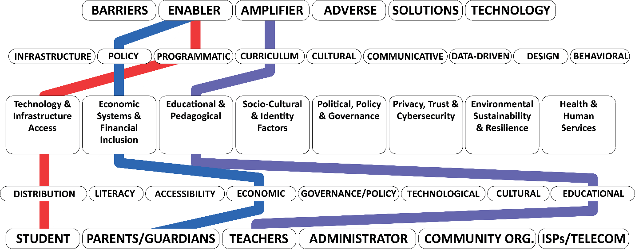

🔴 Path 1 - Student to Enabler
Students → Distribution → Technology & Infrastructure Access
→ Programmatic → Enabler
Hotspots directly enable access by being distributed through district programs.

🔵 Path 2 - Parents/Guardians to Enabler
Parents/Guardians → Economic → Economic Systems & Financial Inclusion
→ Policy → Enabler
Subsidized costs by the device being provided in whole or part and supportive policies enable parents to provide reliable internet access at home.

🟣 Path 3 - Teachers to Amplifier
Teachers → Educational → Educational & Pedagogical
→ Curriculum → Amplifier
Teachers amplify the impact of connectivity at home by integrating digital resources, use of the learning management system, and online assignments into learning.

APPLICATION B
Applying the Model to a
Multiple Dwelling Unit Upgrades
Scenario: An old apartment complex containing 200 apartments is in need of a technological overhaul to provide networking and smart home infrastructure and internet services to the residents.
Stakeholders → Elements (with Application)
Stakeholder | Key Elements | Application in MDU Upgrade
Residents (low-income, seniors, families, remote workers) | Accessibility, Economic, Cultural, Technological | Residents gain affordable broadband, accessibility features, and smart-home tools to improve quality of life.
Apartment Managers / Property Owners | Governance, Policy, Economic, and Infrastructure | Manage contracts, approve upgrades, negotiate with ISPs, and comply with housing regulations.
ISPs / Telecom Providers | Technological, Economic, Regulatory, Product Design | Provide fiber or wireless upgrades, implement pricing models, and ensure compliance with FCC/NTIA rules.
Local Government / Housing Authorities | Political, Regulatory, Policy, Economic | Offer incentives or subsidies, enforce equity requirements, and monitor compliance.
Community Organizations / Digital Navigators | Literacy, Social, Cultural | Help residents adopt new technology, train them on devices, ensure inclusion for vulnerable groups.
Vendors / Hardware Manufacturers (smart home devices, routers, IoT systems) | Technological, Product Design, Accessibility | Supply affordable, secure, and accessible networking equipment.

Elements → Domains (with Application)
Element | Aligned Domains | Application in MDU Upgrade
Accessibility | Socio-Cultural & Identity; Health & Human Services | Smart home systems configured for seniors and residents with disabilities.
Economic | Economic Systems & Financial Inclusion; Sustained Transformation | Affordable service tiers and subsidies for low-income residents.
Technological | Technology & Infrastructure Access; AI & Emerging | Deployment of fiber, Wi-Fi 6, or 5G-ready infrastructure with IoT integration.
Governance / Policy | Political, Policy & Governance; Privacy & Cybersecurity | Local housing codes and FCC compliance govern installations and pricing.
Literacy | Educational & Pedagogical; Stakeholder Engagement | Resident training on safe use of smart-home and internet services.
Cultural | Socio-Cultural & Identity; Educational & Pedagogical | Multilingual support and culturally sensitive outreach to residents.
Product Design | Technology & Infrastructure; Ethical; Privacy | Devices designed for security, ease of use, and equitable access.
Domains → Intervention Roles (with Application)
Domain | Intervention Roles | Application in MDU Upgrade
Technology & Infrastructure Access | Infrastructure, Design, Programmatic | Fiber/Wi-Fi deployment, smart-home wiring, router installations.
Economic Systems & Financial Inclusion | Policy, Programmatic, Behavioral | Subsidized broadband tiers, bulk purchasing models, incentives for adoption.
Educational & Pedagogical | Curriculum, Communicative | Resident training workshops, digital literacy programs.
Socio-Cultural & Identity Factors | Cultural, Communicative, Behavioral | Outreach campaigns in multiple languages, peer mentors for adoption.
Political, Policy & Governance | Policy, Data-Driven, Design | Municipal incentives, federal/state funding, and regulatory oversight.
Privacy, Trust & Cybersecurity | Data-Driven, Communicative, Policy | Secure IoT devices, resident privacy protections, transparent communication.
Sustained Transformation & Adoption | Programmatic, Policy, Design | Long-term contracts with ISPs, upgrade cycles, and maintenance agreements.
Role | Intervention Type(s) | Application in MDU Upgrade
Infrastructure | Enabler, Solution | Installation of fiber, Wi-Fi 6, or CBRS systems enables access.
Policy | Enabler, Barrier | Subsidies and fair housing regulations enable equity; a lack of rules creates affordability barriers.
Programmatic | Solution, Amplifier | District- or city-supported rollout programs amplify adoption.
Curriculum (Training Residents) | Amplifier | Increases adoption and confidence, especially for seniors.
Cultural | Enabler, Amplifier | Multilingual support ensures equitable uptake.
Communicative | Enabler, Adverse | Clear outreach enables trust; poor messaging creates confusion and distrust.
Data-Driven | Enabler, Solution | Usage and adoption data guide improvements and ensure equity benchmarks.
Design | Enabler | Secure and accessible smart-home devices encourage trust and usability.
Behavioral | Amplifier, Adverse | Positive adoption habits amplify benefits; misuse of IoT devices could create adverse cybersecurity risks.
Intervention Roles → Intervention Types (with Application)
Role | Intervention Type(s) | Application in MDU Upgrade
Infrastructure | Enabler, Solution | Installation of fiber, Wi-Fi 6, or CBRS systems enables access.
Policy | Enabler, Barrier | Subsidies and fair housing regulations enable equity; lack of rules creates affordability barriers.
Programmatic | Solution, Amplifier | District- or city-supported rollout programs amplify adoption.
Curriculum (Training Residents) | Amplifier | Increases adoption and confidence, especially for seniors.
Cultural | Enabler, Amplifier | Multilingual support ensures equitable uptake.
Communicative | Enabler, Adverse | Clear outreach enables trust; poor messaging creates confusion and distrust.
Data-Driven | Enabler, Solution | Usage and adoption data guide improvements and ensure equity benchmarks.
Design | Enabler | Secure and accessible smart-home devices encourage trust and usability.
Behavioral | Amplifier, Adverse | Positive adoption habits amplify benefits; misuse of IoT devices could create adverse cybersecurity risks.
Model Application Insights
Model Application Insights
- Infrastructure is necessary but insufficient - The technological upgrades is the enabler, but without literacy, cultural outreach, and affordability programs, adoption will lag.
- Economic sustainability matters - Bulk service contracts or subsidies prevent broadband from becoming a barrier. Residents need affordable options, not just high-speed availability. This may also include multiple vendor options.
- Community adoption hinges on trust - Outreach (cultural + communicative roles) must address privacy, language, and usability, or residents may resist smart-home adoption. An awareness campaign will also be needed before, during, and after the rollout process.
- Policy alignment is critical - City housing authorities and ISPs need aligned policies to ensure equitable service distribution, prevent digital redlining, and enforce long-term commitments to particular providers, which reduces competition in the marketplace. FCC access policies and funding organizations contribute to a multiple vendor environment.
- Feedback loops strengthen outcomes - Data-driven monitoring ensures that the intervention remains an enabler instead of transforming into an adverse outcome (e.g., if costs rise or devices are insecure due to the service or infrastructure rollout).
Visual Insights
- Different actors will experience different outcomes: Residents will see the upgrades as an enabler, ISPs view them as a solution, but property owners could introduce a barrier if costs or incentives aren’t addressed and adoption is poor.
- Policy is the pivot: The property owner path highlights how housing and telecom policy can make or break the program. Without alignment, infrastructure investments won’t translate into adoption.
- Culture and trust matter: Even with infrastructure, residents may hesitate unless communication and design reflect their cultural and accessibility needs, which may include the need for family-level filtering services or education on how to apply filters and internet safeguards.
- System interdependence: For the MDU to succeed, all three pathways must converge—enabling residents, motivating property owners, and incentivizing ISPs simultaneously.
Stakeholder Pathways
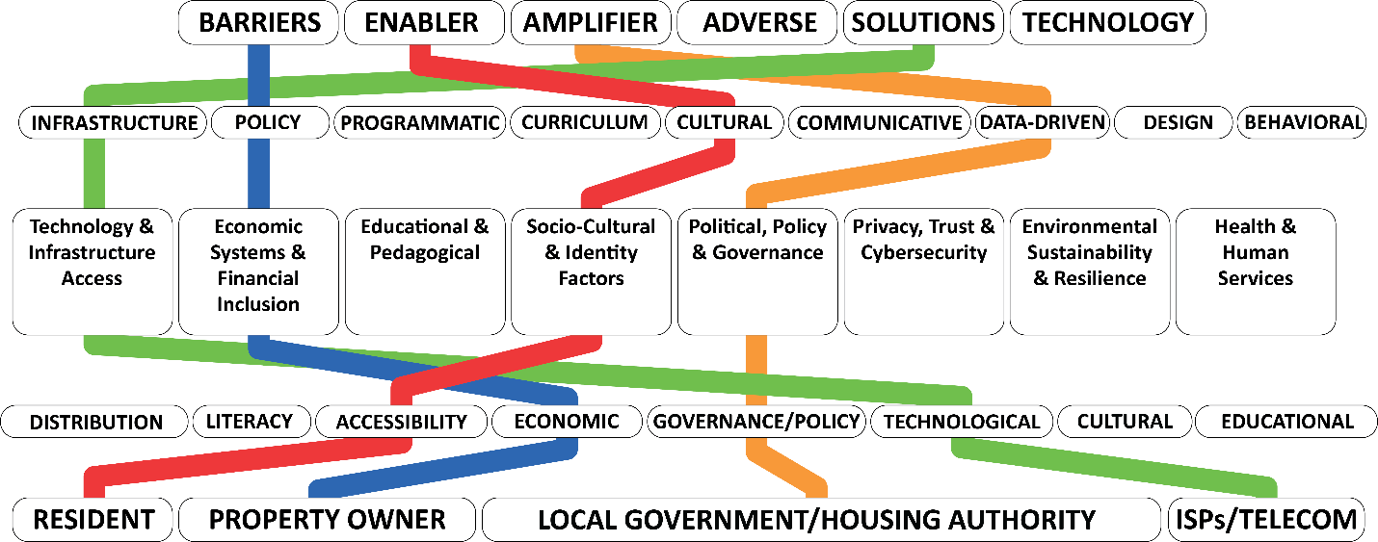
🔴 Resident Pathway → Enabler
Residents → Accessibility → Socio-Cultural & Identity Factors → Cultural → Enabler
Upgrades must be culturally responsive (multilingual outreach, accessible design) so residents can adopt the technology confidently.

🔵 Property Owner Pathway → Barrier
Property Owners → Economic → Economic Systems & Financial Inclusion → Policy → Barrier
If owners or managers resist due to cost, or if housing policies lack incentives, the upgrade risks stalling as an economic barrier.

🟢 ISP Pathway → Solution
ISPs/Telecom → Technological → Technology & Infrastructure Access → Infrastructure → Solution
For ISPs, installing fiber/Wi-Fi infrastructure transforms the MDU into a sustainable solution, provided pricing and access remain equitable.

🟠 Local Government Pathway → Amplifier
Local Government/Housing Authorities → Governance/Policy → Political, Policy & Governance → Data-Driven Role → Amplifier
Governments can amplify success through incentives, oversight, and data-driven monitoring to ensure equity and sustainability.

APPLICATION C
Applying the Model to a
Small Rural Community
Scenario: A small rural community has one service provider in town with no installed fiber to the homes in the community and relies on fixed wireless and cellular communications, with the cellular dependent on where you are. There is funding available a new fiber installation for all homes within the community and support for a network of multiple towers to reach outlying areas in the community.
Matrix A - Stakeholders → Elements (with Application)
Stakeholder | Key Elements | Application in Rural Fiber + Tower Buildout
Residents (farmers, families, seniors, students) | Geographic, Accessibility, Economic, Literacy | Reliable fiber ensures equity of access; training builds adoption; affordability remains critical.
Small Businesses / Farmers | Economic, Technological, Product Design | Fiber enables e-commerce, precision agriculture, and remote work capabilities.
Local Government / Town Council | Governance, Policy, Resource, Political | Oversees grants, negotiates with ISPs, aligns funding with community needs.
ISPs / Telecom Providers (incumbent + potential entrants) | Technological, Infrastructure, Economic, Regulatory | Build and operate fiber/towers, set service pricing, and ensure long-term maintenance.
Community Organizations / Schools / Libraries | Literacy, Social, Educational | Act as anchor tenants, adoption hubs, and training centers.
Federal & State Agencies (NTIA, USDA, FCC, state broadband office) | Regulatory, Economic, Political | Provide funding, set broadband standards, and enforce coverage obligations.
Matrix B - Elements → Domains (with Application)
Element | Aligned Domains | Application in Rural Buildout
Geographic | Technology & Infrastructure; Environmental Sustainability | Fiber + towers designed to overcome terrain; sustainable siting.
Accessibility | Socio-Cultural & Identity; Health & Human Services | Ensure disabled and elderly residents can access and adopt services.
Economic | Economic Systems & Financial Inclusion; Sustained Transformation | Affordability programs, bulk subsidies, tiered service models.
Governance / Policy | Political, Policy & Governance; Privacy & Cybersecurity | Local ordinances, franchise agreements, and compliance rules.
Technological | Technology & Infrastructure Access; AI & Emerging | Fiber-to-the-home (FTTH), Wi-Fi 6/5G towers, IoT for farms.
Literacy | Educational & Pedagogical; Stakeholder Engagement | Training programs at schools, libraries, and community centers.
Resource | Economic Systems; Political/Policy | Allocation of federal/state funds, ensuring accountability.
Matrix C - Domains → Intervention Roles (with Application)
Domain | Intervention Roles | Application in Rural Buildout
Technology & Infrastructure Access | Infrastructure, Design, Programmatic | Laying fiber, installing towers, and backhaul planning.
Economic Systems & Financial Inclusion | Policy, Programmatic, Behavioral | Subsidized pricing, affordability programs, and digital adoption incentives.
Educational & Pedagogical | Curriculum, Communicative, Programmatic | Digital literacy training integrated into schools and libraries.
Socio-Cultural & Identity Factors | Cultural, Communicative | Outreach tailored to rural traditions, languages, and trust networks.
Political, Policy & Governance | Policy, Data-Driven, Design | Oversight of grant spending, transparent reporting, and regulatory design.
Privacy, Trust & Cybersecurity | Policy, Data-Driven | Secure installation of networks and community trust in ISP practices.
Environmental Sustainability & Resilience | Design, Infrastructure, Policy | Tower siting with environmental safeguards; fiber installation resilient to storms.
Matrix D - Intervention Roles → Intervention Types (with Application)
Role | Intervention Type(s) | Application in Rural Buildout
Infrastructure | Enabler, Solution | Fiber and towers provide the physical backbone of connectivity.
Policy | Enabler, Barrier | Grants enable deployment; weak oversight risks barriers like redlining.
Programmatic | Solution, Amplifier | Rural broadband adoption programs amplify the impact of infrastructure.
Curriculum (Training) | Amplifier | Training residents increases adoption and effective use.
Cultural | Enabler, Amplifier | Community buy-in ensures trust; skepticism could reduce uptake.
Communicative | Enabler, Adverse | Transparent rollout plans build confidence; poor messaging leads to confusion or distrust.
Data-Driven | Enabler, Solution | Coverage maps and adoption data guide investment and accountability.
Design | Enabler | Resilient tower placement and user-friendly home installs promote success.
Behavioral | Amplifier, Adverse | Adoption behaviors amplify benefits; misuse or low adoption undermines ROI.
Model Application Insights
- Infrastructure is necessary but not sufficient — installing fiber and towers enables access, but without affordability programs and training, adoption may lag.
- Policy is the amplifier — oversight and accountability ensure funds translate into long-term equity and access implemented.
- Community institutions multiply impact — schools and libraries are critical for turning infrastructure into lived opportunity, providing local evidence of the experience.
- Interdependence across pathways — the community residents’ benefit (enabler), ISPs build (solution), governments amplify, and institutions reinforce adoption. The system fails if any of the pathways collapse.
Stakeholder Pathways
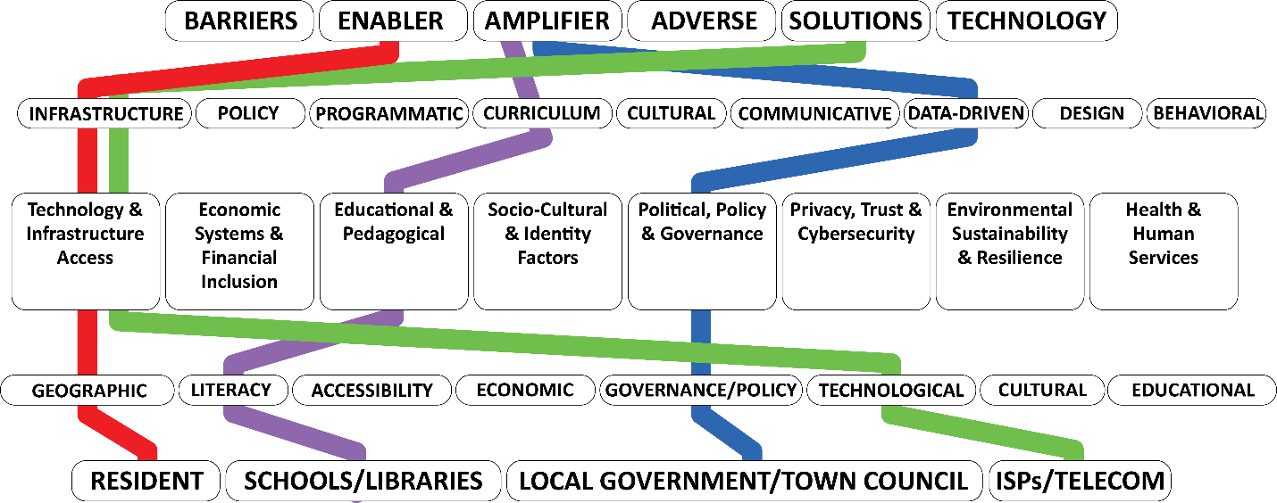

🔴 Resident Pathway → Enabler
Residents → Geographic → Technology & Infrastructure Access → Infrastructure → Enabler
Installed fiber and towers overcome geographic isolation, directly enabling equitable access.

🟢 ISP Pathway → Solution
ISPs/Telecom → Technological → Technology & Infrastructure Access → Infrastructure → Solution
Service providers transform funding into broadband solutions through infrastructure buildout.

🔵 Local Government Pathway → Amplifier
Local Gov/Town Council → Governance/Policy → Political, Policy & Governance → Data-Driven → Amplifier
Government amplifies success enforcing compliance, tracking coverage, and aligning funding with community needs.

🟣 Schools & Libraries Pathway → Amplifier
Schools/Libraries → Literacy → Educational & Pedagogical → Curriculum → Amplifier
Anchor institutions amplify adoption by training residents and embedding digital skills in education.

APPLICATION D
Applying the Model to an
Extreme Remote Residence
There is a single resident in the middle of nowhere with intermittent cellular coverage and fiber installation is physically and cost prohibitive.
Matrix A - Stakeholders → Elements (with Application)
Stakeholder | Key Elements | Application in Extreme Remote Residence
Resident (single household) | Geographic, Accessibility, Economic, Psychological | Limited coverage → frustration, reliance on minimal connectivity; affordability matters if satellite is the option.
Local Government / County | Resource, Policy, Political | Must decide if supporting a single resident is feasible; can connect to state/federal subsidy programs.
ISPs / Satellite Providers | Technological, Economic, Regulatory | Likely solution is satellite broadband (Starlink, HughesNet); may need subsidy.
Federal/State Agencies (FCC, USDA, NTIA) | Regulatory, Economic, Policy | Universal service funds, rural broadband subsidies, or direct support for satellite connections.
Community Orgs / Digital Navigators (if reachable) | Literacy, Social | Provide training/support remotely; help with device setup and troubleshooting.
Matrix B - Elements → Domains (with Application)
Element | Aligned Domains | Application
Geographic | Technology & Infrastructure; Environmental Sustainability | Terrain and isolation make fiber impractical; focus shifts to wireless/satellite.
Accessibility | Socio-Cultural & Identity; Health & Human Services | Ensuring remote residents can access emergency health/education services.
Economic | Economic Systems & Financial Inclusion | Satellite costs are high; subsidies essential.
Resource | Political/Policy; Economic | Federal/state funds must be allocated efficiently; may prioritize extreme cases.
Technological | Technology & Infrastructure Access; AI & Emerging | Satellite, fixed wireless, or hybrid mesh solutions.
Psychological | Health & Human Services | Social isolation can worsen without connectivity; internet is a lifeline.
Matrix C - Domains → Intervention Roles (with Application)
Domain | Intervention Roles | Application
Technology & Infrastructure Access | Infrastructure, Design | Satellite equipment installation; optimized tower placement if feasible.
Economic Systems & Financial Inclusion | Policy, Programmatic | Subsidized satellite service to offset high monthly costs.
Political, Policy & Governance | Policy, Data-Driven | Broadband subsidies applied to edge cases; monitor cost-effectiveness.
Health & Human Services | Programmatic, Communicative | Ensure telehealth is prioritized over entertainment access.
Socio-Cultural & Identity Factors | Cultural, Behavioral | Outreach ensures resident understands limits/benefits of connectivity.
Matrix D - Intervention Roles → Intervention Types (with Application)
Role | Intervention Type(s) | Application
Infrastructure | Enabler, Solution | Satellite dish provides minimum viable broadband.
Policy | Enabler, Barrier | Universal service subsidies enable adoption; lack of policy creates affordability barrier.
Programmatic | Solution | Rural broadband assistance programs provide hardware and setup support.
Cultural | Enabler | Communication in relatable terms builds trust in satellite adoption.
Communicative | Enabler, Adverse | Clear instructions help adoption; poor communication risks underuse.
Data-Driven | Enabler | Monitoring ensures subsidy programs target extreme needs effectively.
Design | Enabler | Equipment designed for easy self-installation improves adoption.
Model Application Insights
- Satellite is the only viable enabler - Fiber installation options are infeasible and not cost effective; towers may not justify cost. Satellite fills the gap.
- Affordability is critical - Without subsidies, satellite becomes a barrier rather than an enabler.
- Connectivity must be prioritized for essentials - Telehealth, education, and emergency services come before entertainment use.
- Policy efficiency - Serving a single household raises cost-benefit questions. Data-driven governance ensures resources are justified. Without subsidies, the resident faces barriers; with them, access becomes sustainable.
- Psychological dimension - Connectivity here is not just economic but sociological, reducing isolation and providing a lifeline.
- Health services show amplification — connectivity here isn’t just about the internet, but about amplifying wellbeing and safety.
- Equity framing is essential — extreme cases highlight the moral and policy challenge of investing in one resident: cost-benefit vs. universal service commitment.
Stakeholder Pathways
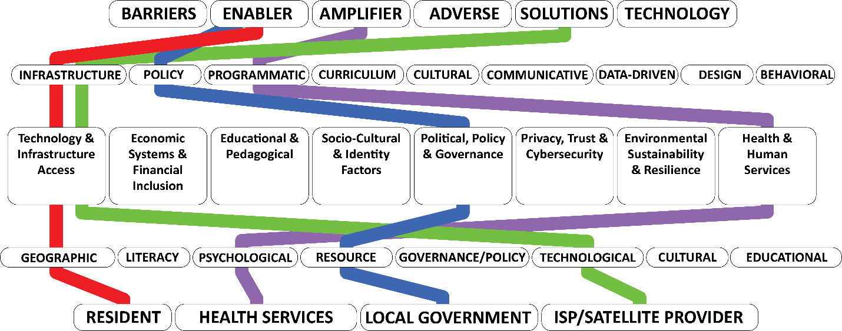

🔴 Resident Pathway → Enabler
Resident → Geographic → Technology & Infrastructure Access → Infrastructure → Enabler
Satellite or fixed wireless becomes the enabler, providing baseline connectivity in isolation.

🔵 Local Government Pathway → Enabler
Local Government → Resource → Political, Policy & Governance → Policy → Enabler
Subsidies and targeted funding turn an otherwise prohibitive solution into an enabler for access.

🟢 ISP/Satellite Provider Pathway → Solution
ISP/Satellite Provider → Technological → Technology & Infrastructure Access → Infrastructure → Solution
Satellite service is the technological solution, delivering essential connectivity.

🟣 Health Services Pathway → Amplifier
Health Services → Psychological → Health & Human Services → Programmatic → Amplifier
Telehealth programs amplify the value of connectivity by addressing isolation and health access needs.

APPLICATION E
Applying the Model to an
Underserved Urban Community
Scenario: In the City of Phoenix, there is an urban underserved neighborhood with multiple providers present, including cellular, and classified by the FCC as a served area, but affordability is the primary barrier, and a second barrier is the mistrust of government schemes and programs designed to provide access.
Matrix A - Stakeholders → Elements (with Application)
Stakeholder | Key Elements | Application in Phoenix Neighborhood
Residents (low-income households, renters, families, seniors, gig workers, students) | Economic, Psychological, Cultural, Accessibility | Internet is technically available but unaffordable; mistrust creates reluctance to sign up for subsidy programs.
Community Organizations (churches, nonprofits, neighborhood groups) | Cultural, Social, Literacy | Act as trusted intermediaries to overcome mistrust and provide digital literacy training.
ISPs / Providers (fiber, cable, wireless, cellular) | Economic, Product Design, Regulatory | Compete in the market but may lack incentive to create truly affordable plans; can design low-cost tiers.
City of Phoenix / Local Government | Political, Policy, Governance | Can facilitate affordability programs, partnerships, and grants, but may face resident mistrust.
FCC / Federal Agencies | Regulatory, Economic, Policy | Define “served” status, distribute Affordable Connectivity Program (ACP) funds, but risk being seen as bureaucratic or mistrusted.
Schools / Libraries (anchor institutions) | Educational, Communicative, Cultural | Can serve as trusted adoption points for families and students.

Matrix B - Elements → Domains (with Application)
Element | Aligned Domains | Application
Economic | Economic Systems & Financial Inclusion; Sustained Transformation | Internet service cost is the main barrier; subsidy design is critical.
Cultural | Socio-Cultural & Identity; Educational & Pedagogical | Mistrust of government requires culturally rooted outreach via community leaders.
Psychological | Health & Human Services; Socio-Cultural | Fear of scams, skepticism of “free internet” offers; trust-building is required.
Accessibility | Technology & Infrastructure Access; Educational | Ensuring affordable devices and plans are available to supplement access.
Governance / Policy | Political, Policy & Governance; Privacy | Oversight of affordability programs and transparency in implementation.
Literacy | Educational & Pedagogical; Stakeholder Engagement | Digital literacy support is needed to maximize benefits once access is achieved.

Matrix C - Domains → Intervention Roles (with Application)
Domain | Intervention Roles | Application
Economic Systems & Financial Inclusion | Policy, Programmatic, Behavioral | ACP-style subsidies; municipal programs; behavioral nudges toward adoption.
Socio-Cultural & Identity Factors | Cultural, Communicative | Trusted community messengers deliver outreach; avoid top-down approaches.
Health & Human Services | Communicative, Programmatic | Position connectivity as essential for health access (telehealth) and safety.
Educational & Pedagogical | Curriculum, Programmatic, Communicative | Digital literacy courses at schools/libraries support families.
Political, Policy & Governance | Policy, Data-Driven, Design | City/federal oversight of affordability programs; transparency to rebuild trust.
Technology & Infrastructure Access | Design, Product, Infrastructure | Affordable service tiers, prepaid plans, and community Wi-Fi options.

Matrix D - Intervention Roles → Intervention Types (with Application)
Role | Intervention Type(s) | Application
Policy | Enabler, Barrier | Well-designed subsidies enable access; bureaucratic complexity becomes a barrier.
Programmatic | Solution, Amplifier | Local nonprofits running enrollment drives amplify adoption.
Cultural | Enabler, Amplifier | Trusted leaders amplify uptake; ignoring culture reinforces barriers.
Communicative | Enabler, Adverse | Transparent messaging builds trust; poor messaging feeds mistrust.
Curriculum (Digital Literacy) | Amplifier | Improves meaningful adoption once affordability is addressed.
Behavioral | Amplifier, Adverse | Nudges toward participation amplify use; distrustful behavior undermines outcomes.
Design | Enabler | Low-cost plan design and prepaid/no-credit checks enable adoption.
Data-Driven | Enabler | Transparent reporting proves impact, building trust.

Model Application Insights
- Infrastructure is not the issue - The community is technically “served” according to local mapping data and by the FCC. The model shows how barriers are shifted upward into the economic and cultural domains.
- Trust deficit is as critical as cost - Policy alone can’t solve affordability without trusted partners (community organizations, schools, libraries as examples).
- ISPs can innovate at the design level - Affordable plan design (prepaid, no-credit-check) turns a structural barrier into a solution. ISPs can get creative in developing service plans that can shift affordability from a barrier to a solution.
- Programs risk becoming adverse - Without transparent communication, support for languages, subsidies, and government efforts risk reinforcing mistrust.
- Amplifiers are social, not technical - Community anchor institutions can amplify adoption by embedding digital equity into everyday institutions and service delivery to demonstrate the value of access through adoption and skill-building.
- Policy is fragile here — it can be either a strong enabler or a strong adverse factor depending on design and perception of the policy by the residents and the community.
Stakeholder Pathways
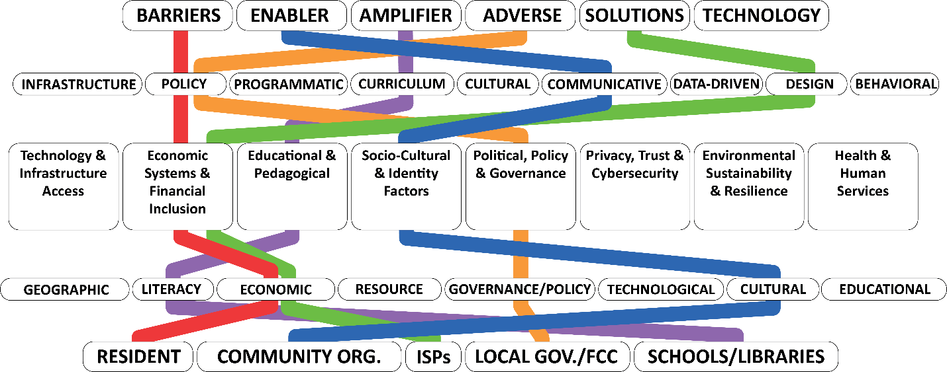

🔴 Resident Pathway → Barrier
Residents → Economic → Economic Domain → Policy → Barrier
Although infrastructure exists, affordability programs often feel inaccessible or burdensome, turning policy into a barrier.

🔵 Community Org Pathway → Enabler
Community Orgs → Cultural → Socio-Cultural Domain → Communicative → Enabler
Trusted messengers (churches, nonprofits) bridge the trust gap, reframing access programs in culturally relevant ways.

🟢 ISP Pathway → Solution
ISPs → Economic → Economic Domain → Design → Solution
Providers can offer prepaid, low-cost, or no-credit-check plans as a concrete solution to affordability issues.

🟠 Local Gov/FCC Pathway → Adverse (or Enabler if done well)
Local Gov/FCC → Governance/Policy → Political Domain → Policy → Adverse
Government programs risk being seen as bureaucratic or deceptive, flipping intended enablers into adverse outcomes.

🟣 Schools & Libraries Pathway → Amplifier
Schools/Libraries → Literacy → Educational Domain → Curriculum → Amplifier
Anchor institutions amplify adoption by embedding digital equity into trusted educational environments.

Model Overview
Stakeholders
1. Individual (14)
Students, parents, guardians, teachers, faculty, adult learners, job seekers, independent researchers, freelance educators, home-school educators, recent graduates, people with disabilities, non-native language speakers, rural residents, and low-income individuals.

2. Community (12)
Neighborhood associations, parent–teacher organizations, local nonprofits, community centers, public libraries, senior centers, afterschool programs, grassroots advocacy groups, cultural heritage groups, faith-based organizations, community-based broadband cooperatives, and local civic clubs.

3. Organizational (12)
School superintendents, boards of education, public universities, private universities, community college presidents, charter school network executives, vocational and technical school directors, adult education program coordinators, online learning institution leaders, state education agency directors, public health department directors, and workforce development board chairs.

4. Societal (9)
Federal education agency leaders, national advocacy coalition directors, major philanthropic foundation executives, international education organization leaders, standards-setting body chairs, national teacher association presidents, global educational alliance coordinators, multinational humanitarian organization heads, and national curriculum council chairs.

5. Intermediary (9)
Regional education service agency directors, state library system administrators, nonprofit education alliance leaders, broadband consortium managers, edtech professional association presidents, grantmaking intermediary program officers, technology training hub directors, state-level digital equity office leads, and workforce intermediary organization executives.

6. Private Sector (9)
Chief executives of internet service providers, telecom company regional directors, educational technology company product managers, device manufacturing executives, software development leads, corporate social responsibility directors, workforce training vendor managers, cloud service provider executives, and AI technology firm ethics officers.

7. Philanthropic & Nonprofit (9)
Executive directors of national philanthropic foundations, community foundation program officers, education-focused grant makers, mission-driven nonprofit CEOs, global development NGO directors, nonprofit research organization leaders, charitable trust managers, national literacy organization executives, and technology access nonprofit coordinators.

8. Academic & Research (9)
University presidents, provosts, deans of education, education policy research center directors, lead academic researchers, think tank fellows, independent program evaluators, heads of research consortia, and educational data analytics firm leads.

9. Media & Public Awareness (9)
Education journalists, local news editors, national news organization bureau chiefs, educational YouTubers, social media influencers, advocacy campaign media strategists, public broadcasting executives, community radio hosts, and education-focused podcast producers.

10. Government & Public Policy (11)
Mayors, city council members, county commissioners, state broadband office directors, U.S. Department of Education senior officials, Federal Communications Commission commissioners, NTIA department and program leads, tribal government leaders, state legislators, congressional education committee members, and national education ministry officials.

Stakeholders Lenses

1. Individual
A single person who is directly impacted by or engaged in digital inclusion efforts, either as a learner, educator, parent, or citizen. Their experiences, skills, and adoption of technology shape the outcome of digital divide initiatives.
Example Stakeholders: Students, parents/guardians, teachers, adult learners, job seekers.

2. Community
A geographically or culturally connected group of individuals sharing resources, needs, or advocacy goals. In digital divide work, communities are both the beneficiaries and partners in co-creating equitable access solutions.
Example Stakeholders: Local nonprofits, community centers, public libraries, grassroots coalitions.

3. Organizational
Structured institutions with authority, resources, and operational capacity to implement or influence digital equity strategies. They operate programs, manage infrastructure, and set institutional priorities.
Example Stakeholders: School districts, universities, workforce development boards, and education consortia.

4. Societal
The broader national and global systems, norms, and structures that establish the conditions for access and equity. This lens includes entities that shape law, culture, and large-scale policy.
Example Stakeholders: Federal agencies, global organizations, philanthropic networks, standards bodies.

5. Intermediary
Organizations or networks that operate between funders/policymakers and local implementers, adapting large-scale strategies to local contexts, brokering partnerships, and providing technical assistance.
Example Stakeholders: Regional education service agencies, state library systems, broadband coalitions.

6. Private Sector
For-profit entities and market actors that design, build, and deliver technologies, connectivity, and services, or provide financial and strategic support for digital equity efforts.
Example Stakeholders: ISPs, telecom companies, device manufacturers, edtech firms, and corporate social responsibility programs.

7. Philanthropic & Nonprofit (New)Charitable foundations, Grantmakers, and mission-driven nonprofits that invest financial, research, and advocacy resources into closing the digital divide, often testing and scaling innovative solutions.
Example Stakeholders: Bill & Melinda Gates Foundation, local community foundations, national education nonprofits.

8. Academic & Research (New)
Universities, think tanks, and independent research organizations that study, evaluate, and inform policy and practice, providing evidence-based insights and neutral convening power for stakeholders.
Example Stakeholders: Education policy research centers, academic researchers, and independent evaluators.

9. Media & Public Awareness
Media organizations, journalists, and digital content creators who influence public perception, raise awareness, and drive community engagement on digital equity issues.
Example Stakeholders: Education journalists, local news outlets, educational YouTubers, and advocacy campaign media partners.

10. Government & Public Policy
Local, tribal, state, and federal government bodies that set regulations, provide funding, and establish legal frameworks for connectivity, access, and educational equity.
Example Stakeholders: City councils, state broadband offices, U.S. Department of Education, FCC.

Domains Defined
Economic Systems and Financial Inclusion
This domain refers to the structural and individual economic conditions that shape access to digital tools and services in education. It includes household income levels, institutional budgets, and economic facets that directly influence and impact the affordability and sustainability of technology. Financial inclusion within this domain involves policies, pricing models, schemes, private and publicly supported, that reduce the cost or provide subsidies for access and services for the purposes of affordability, internet service, devices, and software, particularly for low-income means-tested learners and families, and under-resourced schools through programs like the USAC ERATE.

Privacy, Trust, and Cybersecurity
This domain addresses the ethical, technical, and legal dimensions of protecting user data and building trust in digital tools for safe online environments. In education, it includes compliance with data privacy regulations (e.g., FERPA, HIPAA, COPPA), managing cybersecurity risks, and ensuring that learners and educators understand how to use digital platforms securely and responsibly. This domain also emphasizes the importance of trustworthy technology use, especially for vulnerable populations who have been the target of many programs, schemes, and efforts to close the digital divide since the 1980s.

Political, Policy, and Governance
This domain encompasses the governmental, institutional, and regulatory frameworks that shape digital equity efforts. It includes laws, policies, and public leadership that guide funding allocations, broadband strategies, edtech procurement, and curriculum standards. Governance also includes decision-making practices at the district or institutional level, ensuring that equity is embedded in strategic planning and resource distribution.

Educational and Pedagogical Systems
This domain focuses on the integration of digital tools into teaching, learning, assessment, and curriculum design. It addresses how pedagogy adapts to leverage technology, how educators are prepared and supported in tech-enhanced instruction, and how digital learning is made accessible to diverse learners. This includes inclusive instructional practices, adaptive learning, and multimodal delivery, ensuring equity in both physical and virtual learning spaces.

Stakeholder Engagement and Empowerment
This domain involves the active participation of students, parents, teachers, administrators, and community members in designing, implementing, and improving digital education initiatives. It emphasizes inclusive engagement practices that amplify marginalized voices and support learners beyond access—focusing on empowerment through training, feedback loops, and local agency. This domain ensures solutions are community-informed, user-centered, and co-created.

Post-Access Adoption and Use
This domain examines what happens after basic access to technology is achieved. It focuses on meaningful use, sustained engagement, and outcomes of technology adoption in learning environments. This includes digital literacy, motivation, ease of use, content relevance, and the availability of support systems that ensure continued, effective, and equitable utilization of digital resources over time.

Technology and Infrastructure Access
This domain represents the physical and digital infrastructure required for equitable technology use, including broadband, Wi-Fi, cloud services, hardware, and maintenance support. It encompasses both institutional (e.g., campus networks, data centers) and personal (e.g., home broadband, personal devices) infrastructure, and focuses on ensuring reliable, affordable, and scalable access across geographic and demographic contexts.

AI and Emerging Technologies
This domain explores how artificial intelligence, machine learning, automation, and emerging digital tools (e.g., AR/VR, blockchain, smart devices) are integrated into educational systems. It includes an analysis of opportunities, ethical concerns, algorithmic bias, and equity implications of these technologies, ensuring they do not replicate or amplify existing divides but instead contribute to inclusive innovation in education.

Socio-Cultural and Identity Factors
This domain examines how race, ethnicity, gender, language, disability, religion, and cultural identity affect experiences with digital education. It highlights the importance of cultural relevance, identity validation, and anti-bias design in edtech solutions. This domain calls for equity-aware practices that recognize intersecting identities and respond to the needs of diverse learners and communities.

Labor Market and Workforce Development
This domain links education with future employability and economic mobility, focusing on the digital skills required for participation in a modern workforce. It includes alignment between curricula and labor market demands, support for digital credentialing, and access to career-relevant technologies. The domain ensures students, especially from underserved communities, can transition from education into equitable employment opportunities in digitally evolving industries.

Health and Human Services
This domain addresses the intersection of digital access with physical and mental health, disability services, and socio-emotional support. It recognizes that digital inclusion is also a public health concern—particularly in telehealth, accessibility accommodations, and wellness-related edtech tools. Equity in this domain ensures that digital services promote not only academic success but also well-being, inclusion, and support for all learners.

Environmental Sustainability and Resilience
This domain focuses on the environmental impacts of digital technology in education, including e-waste, energy consumption, and carbon emissions. It also addresses climate-resilient infrastructure, especially for communities vulnerable to natural disasters or unstable power systems.
Elements (31)

Access & Infrastructure
- Accessibility
- Technology & Infrastructure Access (including redundancy, reliability, geographic coverage)
- Sustainable Technology Management (device lifecycle, e-waste, green IT)
Cultural & Social Factors
- Cultural & Linguistic Inclusion (cultural safety, language/localization, representation in content)
- Social & Community Networks (peer mentoring, digital navigators, local advocacy)
- Historic Preservation
Economic & Financial
- Economic Conditions & Affordability (cost of ownership, funding mechanisms)
- Financial Inclusion in Technology Access
Educational & Pedagogical
- Educational Institutions (K–12, higher ed, vocational, adult, online)
- Instructional Technology Integration
- Assessment Equity
- Content Relevance & Curriculum Adaptation
- Work-Based & Career-Integrated Learning
Governance & Policy
- Policy & Regulatory Frameworks
- Political Context & Governance Capacity
- Advocacy & Procurement Practices
Digital Skills & Capacity
- Knowledge & Digital Literacy
- Digital Motivation & Adoption Readiness
- Digital Safety Awareness
- Digital Health Literacy
Community Empowerment
- Individual Agency & Empowerment
- Institutional Readiness & Capacity Building
- Community Capacity Building
- Participatory & Co-Design
- Tribal Communities
Ethics & Emerging Technologies
- Ethical Use of Technology
- Algorithmic Bias
- Ethical AI Use & Tech Foresight
- Platform Governance
Geographic & Environmental Context
- Environmental & Land Assessments
- Wellness & Resilience Impact Monitoring

Intervention Roles
Intervention Roles describe the functional impact that an element, action, or system has on the digital divide within a specific context. Each role characterizes the way a factor influences the outcome, either by hindering, enabling, intensifying, resolving, or embodying a form of technological change. These roles are not static; a single element (e.g., a technology or policy) may shift roles depending on context, implementation, or stakeholder experience.

The primary intervention roles include:

Barrier: An obstacle that prevents access, adoption, or benefit from digital tools and resources.
Enabler: A catalyst that facilitates or unlocks access, engagement, or equity in digital environments.
Amplifier: A force that intensifies the effects (positive or negative) of another intervention, scaling its reach or impact.
Adverse: An unintended or negative consequence that increases inequities or introduces new forms of exclusion.
Solution: A direct action, tool, or policy that mitigates or resolves an identified barrier or gap in digital equity.
Technology: A platform, system, or device that can serve as infrastructure, content delivery, or innovation—its role depends on how it is designed, governed, and applied.

Intervention Types
Intervention Types refer to the operational mode or implementation method through which an intervention is delivered, governed, or experienced. Each type of intervention captures a category of activity, tool, or strategy that can be mapped to various intervention roles, providing a way to describe how interventions function in an educational context.

The core intervention types include:

Policy: Legislation, mandates, or institutional rules that set direction, allocate resources, or enforce standards.
Practice: Day-to-day behaviors and routines carried out by educators, students, or institutions that shape digital equity experiences.
Design: The intentional structuring of technologies, systems, or experiences with user-centered and inclusive principles.
Infrastructure: Physical and digital systems (e.g., networks, devices, platforms) required to support equitable access and use.
Curriculum: Educational content and pedagogical frameworks that embed digital learning and digital literacy skills.
Programmatic: Structured services or initiatives (e.g., device loan programs, training cohorts) aimed at delivering equitable outcomes.
Behavioral: Individual or group-level psychological and social factors influencing adoption and engagement.
Data-Driven: Use of analytics, algorithms, or artificial intelligence to inform decisions, personalize experiences, or allocate resources.
Cultural: Norms, beliefs, and identity-based practices that influence the reception and relevance of digital tools.
Communicative: Messaging, language, and information-sharing strategies that promote awareness, trust, or engagement.

Intervention Types describe the "how" of a digital equity effort in that how barriers are addressed, solutions deployed, or technologies experienced. They help classify interventions by their delivery mechanism, governance structure, or engagement strategy.

Education: Key Elements and Domain Mapping
Accessibility: In the context of digital education, accessibility means ensuring that all learners including those with disabilities or special needs have an equal opportunity to access and benefit from educational technology. This involves designing digital tools and content with features like text-to-speech, captions, screen-reader support, and adaptive interfaces so that every student can participate fully. True accessibility removes technical and design barriers, providing equal treatment in the use of educational technology for learners of all abilities.
Cultural: The cultural dimension refers to the recognition and inclusion of diverse cultural backgrounds, values, and practices in digital education. Culturally responsive approaches strive to make technology and content relevant and respectful to learners’ heritage and identities. For example, offering multilingual user interfaces and locally relevant examples helps honor cultural diversity. Neglecting this can marginalize certain groups when languages or cultural contexts are excluded in digital content, the cultures they represent are likewise pushed aside. In short, cultural relevance in ed-tech ensures that students from different backgrounds feel represented and engaged.
Economic: Economic factors encompass how socio-economic conditions and income disparities affect digital equity in education. At a broad level, wealth influences whether schools and families can afford devices, internet connectivity, and up-to-date software. The classic “digital divide” was first defined by the uneven distribution of technology resources along economic lines. For instance, higher-income households and well-funded schools are far more likely to provide high-speed Internet and multiple devices per student. Thus, economic inequities can translate into digital inequities, impacting students’ ability to access online learning and develop digital skills. (This also links to future workforce opportunities, as digitally underserved students may be less prepared for modern jobs.)
Educational: This element refers to the pedagogical and curricular aspects of digital equity, how education systems, teaching practices, and learning content integrate technology in fair and effective ways. It covers whether teachers are trained to use tech in the classroom, if curricula leverage digital tools to enhance learning for all, and if online resources align with learning needs. When used appropriately, technology can “help affirm and advance relationships … reinvent approaches to learning … and shrink long-standing equity and accessibility gaps” in education. The educational dimension ensures that digital tools are not just available but are woven into teaching strategies in an inclusive manner (e.g., using adaptive learning software to meet each student’s needs). It also means monitoring outcomes, making sure all students, not only the privileged, benefit academically from ed-tech.
Environmental: The environmental dimension has two main facets in digital equity. First, it considers how the physical environment and infrastructure (e.g., electricity, climate, geography) impact access to technology. Students in remote or disaster-prone regions may struggle with connectivity if, for example, a hurricane knocks out broadband or if there is no reliable power grid. When climate-fueled disasters strike, those on the wrong side of the digital divide can find themselves cut off from crucial warnings and online resources, highlighting the need for resilient infrastructure in all communities. Second, this element touches on environmental sustainability, ensuring that the push for digital learning (and devices, data centers, etc.) is done responsibly, without exacerbating e-waste or environmental injustice. In sum, environmental context can either facilitate or hinder equitable digital education, and sustainable planning is required so that all learners have continuous access, even under challenging conditions.
Ethical: The ethical dimension involves the principles of fairness, responsibility, and integrity in the use of digital technology for education. This includes addressing issues like data privacy (e.g., protecting student data and consent), academic honesty (e.g., preventing AI-driven cheating), and the broader impacts of technology on student well-being. A key concern is algorithmic fairness, ensuring that educational software or AI does not discriminate against any group. Algorithmic bias, for example, occurs when an algorithm unintentionally encodes societal prejudices and produces discriminatory outcomes. In education, this could mean a learning platform that underestimates the abilities of students from a certain background due to biased training data. Ethical digital equity demands transparency and accountability from ed-tech providers and educators: technology should be used in ways that uphold students’ rights, promote inclusion, and avoid harm (such as cyberbullying or excessive surveillance). It also means engaging students in understanding the ethical use of technology.
Financial: The financial element focuses on the costs and affordability associated with digital learning. Even when infrastructure exists, many learners or schools face financial barriers for example, monthly broadband fees, the price of laptops or tablets, or subscription costs for software. Digital equity initiatives emphasize making these costs sustainable and minimal for disadvantaged groups (through subsidies, low-cost programs, etc.). In practice, financial inclusion in ed-tech means offering “affordable, robust broadband internet service” and low-cost devices as baseline requirements. It also extends to funding models: schools need budgeting for device maintenance and upgrades, and communities need investments in libraries, computer labs, or loan programs. If the financial burden of technology is too high, access and use remain unequal. Therefore, addressing the financial dimension is about ensuring affordability so that economic hardship does not translate into digital exclusion.
Geographic: Geographic factors refer to how one’s location (region, country, urban vs. rural setting) affects digital equity. There are stark differences in technology access between different areas: urban students often enjoy high-speed connections and dense network infrastructure, whereas rural students may have limited or no broadband options. At the global scale, geography plays a role in determining which countries or regions have advanced ICT and which are underserved. Indeed, definitions of the digital divide have expanded to include “uneven distribution of technology between countries and global regions,” for example, comparing high connectivity in parts of East Asia or Europe with low connectivity in parts of sub-Saharan Africa or remote islands. Geographic isolation can lead to higher costs and latency (e.g., satellite internet) or weaker tech support and training. This element, then, is about recognizing and addressing spatial disparities: ensuring rural broadband deployment, connecting hard-to-reach communities, and tailoring solutions to local geographic needs so that a student’s learning opportunities aren’t limited by their coordinates on the map.
Individual: The individual dimension highlights personal-level factors, such as the unique circumstances, skills, and attributes of each learner, that affect their ability to benefit from digital education. Even with the same technology in hand, individuals can have different outcomes due to differences in things like digital skills, learning styles, motivation, age, or disabilities. For instance, a tech-savvy student might navigate online resources easily, whereas another student might not know how to troubleshoot problems or might be anxious about using computers. Research on digital inequity notes that it’s “a divide between people who know about ICT and those who don’t, between people who realize the opportunities presented by ICT and those who don’t”. This underscores that personal knowledge and mindset matter. The individual element also involves tailoring digital learning to personal needs, e.g., providing one-on-one support, self-paced modules, or assistive tools so each learner can progress. Ultimately, digital equity must account for human differences at the individual level: no two learners are identical, so flexibility and personal support are key to inclusive education.
Institutional: Institutional factors concern the role of organizations, especially schools, districts, universities, and libraries, in shaping digital equity. Different institutions have varying capacities, policies, and cultures around technology. This dimension looks at whether an institution has the leadership, resources, and policies to support equitable digital learning. For example, one school might have a strong technology plan (providing every student a device, training teachers, robust IT support), while another school lacks funding and has outdated computers. Such disparities were evident even in early accounts of the digital divide a 1996 article contrasted a less affluent school (with a single old PC for students) against a wealthier school where students had modern computers at home. Institutional commitment can determine if digital initiatives succeed: it includes budgeting for tech, setting rules for safe and fair use, implementing inclusive practices (like content filtering that doesn’t over-block, or flexibility for students without home internet), and partnering with community programs. In short, equitable policy and support at the institutional level are necessary so that digital equity is not left to individual teachers or students alone.
Knowledge: The knowledge dimension pertains to information awareness and know-how in the context of digital equity. It addresses the knowledge gap that can exist even when access is present, the gap between those who have information, skills, and awareness about digital opportunities and those who do not. This includes knowing what technologies are available, how to use them effectively, and why they are beneficial. The digital divide is not only about physical access; “it’s also a divide between people who know about ICT and those who don’t”. For example, a family might have an internet connection, but if they are unaware of free online educational resources or lack the knowledge to detect misinformation, they remain at a disadvantage. In education, this element underscores the importance of digital literacy education (teaching students how to search for reliable information, how to use new tools) and awareness campaigns for families (so parents know about discounted internet plans or library tech services). Bridging the knowledge dimension means empowering all stakeholders with the information and understanding needed to make full use of digital resources, turning access into meaningful use.
Literacy: Literacy in digital equity specifically refers to digital literacy the skills and competencies needed to navigate and use digital technologies effectively. This goes beyond basic reading/writing literacy to include the ability to find information online, evaluate its credibility, create content, and communicate safely and effectively in digital spaces. According to the American Library Association’s definition (as echoed by NDIA), “Digital Literacy is the ability to use information and communication technologies to find, evaluate, create, and communicate information, requiring both cognitive and technical skills.”. A person with strong digital literacy can troubleshoot common tech issues, protect their privacy with good passwords, distinguish fact from misinformation, and utilize software for learning or productivity. In an educational context, improving digital literacy for students (and teachers) is crucial for true equity; otherwise, providing devices without guidance simply reinforces gaps. Literacy programs might teach online research skills, critical thinking about media, or basic coding and digital content creation. Digital literacy is also linked to civic participation and workforce development (a digitally literate student is better prepared for modern jobs and informed citizenship). Thus, this element is about ensuring everyone has the skills to turn connectivity into opportunity.
Policy: Policy elements encompass the formal laws, regulations, and strategies set by governments or educational authorities to promote digital equity. This includes national/state education technology policies, school district tech plans, and broader telecom or broadband policies that affect schools. Strong policy support can manifest as funded programs (e.g., a government initiative to provide rural schools with internet), guidelines/standards (such as accessibility requirements for digital content, or student data privacy laws), and integration of digital equity goals into educational reform. Effective digital equity policy provides a roadmap and resources for closing gaps, for example, the U.S. E-rate program that subsidizes school internet, or a Ministry of Education mandating digital skills curriculum across all schools. On the other hand, a lack of policy or a misaligned policy can leave gaps unaddressed. In short, this element is about the governance framework: how leaders plan and legislate to ensure every learner has the tech access and support they need.
Political: The political dimension refers to the influence of politics, power dynamics, and government priorities on digital equity. It acknowledges that achieving equitable access and use of technology is not just a technical or educational issue, but a political one as well. Political will is often necessary to allocate resources or enact policies for digital inclusion. For instance, a local government’s commitment to expand municipal broadband, or a country’s leadership deciding to make digital education a budget priority, can significantly narrow the divide. Conversely, political factors can also hinder equity. Partisan disagreements might block funding for infrastructure, or censorship and political control of the internet might limit educational content in some regions. The global political economy plays a role: international aid or development programs supporting ICT in education are subject to political climates. In education, the political element may involve school board decisions, advocacy by stakeholders (parents, educators) for tech funding, and the broader governance context in which educational technology is deployed. Ultimately, this dimension highlights that equitable ed-tech is a matter of social choice and leadership, requiring engagement with the political process and governance structures to champion the cause of digital equity.
Psychological: The psychological element addresses the mental and attitudinal factors that affect whether individuals embrace and effectively use digital tools for learning. Even with available technology, factors such as technophobia (fear of technology), low self-confidence in using computers, resistance to change, or lack of perceived relevance can create a psychological barrier to digital equity. Researchers note a “psychological gap” in the digital divide, referring to differing comfort levels and attitudes toward ICT For example, an older adult learner or a teacher not accustomed to technology might feel anxiety using an e-learning platform, hindering their participation. Students might experience frustration or low self-efficacy if they encounter challenges online without support. This dimension also covers motivation and mindset, whether a student believes that technology can help their learning (growth mindset) or not. To address the psychological aspect, interventions might include providing mentoring and encouragement, building user-friendly interfaces to reduce intimidation, fostering a positive attitude towards innovation, and addressing issues like digital addiction or stress for a healthy balance. The psychological element reminds us that human factors, such as confidence, beliefs, and emotional readiness, are key to truly inclusive digital education.
Regulatory: The regulatory dimension deals with the rules and regulatory frameworks governing digital technologies and their use in education. This can include data protection laws (like GDPR or COPPA) that regulate student data privacy, telecommunications regulations that influence internet affordability and competition, and standards bodies that set accessibility or interoperability standards. Good regulatory policies can promote equity, for instance, regulations that require internet providers to offer low-cost broadband options or that enforce closed captioning and other accessibility features in educational media. On the other hand, a lack of regulation (or poorly designed rules) can allow inequities to persist or worsen. There is increasing urgency to design inclusive regulatory frameworks that keep up with emerging tech in schools. For example, as AI tools enter classrooms, regulators are exploring how to prevent algorithmic bias or protect against harmful content. Another facet is regulatory support for innovation: enabling schools to use open-source or community networks without legal barriers. In summary, the regulatory element is about the legal environment, ensuring that laws and regulations create a fair, safe, and accessible digital education ecosystem. This might mean updating telecom policies to improve competition and affordability of internet access, or crafting clear regulations around cybersecurity and student rights online.
Resource: The resource element highlights the tangible and intangible resources required for digital learning and how their distribution affects equity. Key resources include devices (computers, tablets, smartphones), internet connectivity, and power/electricity, as well as human resources like tech support staff and teacher training. Equitable education technology requires that all learners have sufficient access to these resources. For example, if only some students have a personal laptop or only some schools have high-bandwidth internet, disparities will arise in the learning experiences. Digital inclusion efforts identify multiple necessary resources, not only affordable broadband, but also “internet-enabled devices that meet the needs of the user,” plus training and support. This element also covers digital content and software as resources: availability of quality online learning materials, educational software licenses, and even parental support or community centers that extend access beyond school hours. A related concept is resource allocation, making sure that investments in technology reach under-resourced schools and groups (for instance, through grants or philanthropic programs). The resource dimension asks: do all students and teachers have the tools, connectivity, and support required to participate in digital learning? Bridging resource gaps from hardware to know-how is fundamental to achieving digital equity.
Social: The social element refers to community and interpersonal factors that influence digital equity. This includes the support (or lack thereof) that learners receive from family, peers, and the wider community in using technology, as well as social norms around technology use. For example, a student whose family values education and can help with homework on a home computer may advance faster than a student whose family is unable to provide such support. Community initiatives like local digital literacy classes, after-school programs, or tech mentorships are social supports that can improve equity. Additionally, social factors include the role of networks and relationships, how peer influence or community champions can encourage technology adoption. Collaborative efforts are key: strong digital equity ecosystems often involve schools partnering with libraries, nonprofits, and community leaders to reach marginalized groups. Indeed, a “Digital Inclusion Ecosystem” is marked by collaboration among local service providers, policymakers, social service agencies, and community leaders working together. The social dimension also considers issues like social isolation or stigma for instance, students who lack internet at home might feel shame or be excluded from discussions. Addressing the social element means fostering an environment where everyone is encouraged and helped to get online and use tech for learning, and leveraging community strengths to support those left behind.
Sociological: The sociological element looks at broader societal structures and demographics and how they systematically impact digital equity. This includes factors like race, ethnicity, gender, class, and other identity variables, as well as historical and structural inequalities that parallel the digital divide. For instance, sociological analysis of digital equity may examine why marginalized racial or ethnic communities have lower internet adoption, or how gender dynamics play out in STEM education and computer access. Studies have noted that digital inequity is driven by overlapping factors a “new digital divide” might be “driven by the intersection of race and gender”, meaning women of color, for example, could face compounded disadvantages in digital access and representation. This dimension prompts us to query: who in society is systematically disadvantaged in the digital realm, and what structural barriers (like poverty, segregation, discrimination) contribute to that? It overlaps with the cultural and social dimensions, but with an emphasis on social science perspectives and equity. In practice, addressing the sociological element may involve targeted inclusion efforts (e.g. programs for girls in tech, outreach in low-income neighborhoods, content that reflects diverse voices) and confronting structural bias (e.g. biased algorithms or lack of representation in IT fields). It’s about understanding digital equity not just at an individual or local level, but as part of larger patterns of social inequality and then working to change those patterns.
Technological: The technological dimension pertains to the tech infrastructure and tools themselves their availability, quality, and evolution. It asks whether the necessary technology (networks, hardware, software platforms) is present and up to task for all users. Key aspects include internet bandwidth and coverage, device specifications and age (new vs. outdated computers), and the interoperability or user-friendliness of educational technology. It also covers emerging technologies like AI, VR, or data analytics in education ensuring these innovations do not widen gaps but rather serve all learners. Many countries have made progress expanding infrastructure (e.g. broadband) to deliver education on a larger scale, yet “connectivity and technology equity barriers still exist”. For example, one school might have cutting-edge smart boards and high-speed fiber internet, while another relies on dial-up or shared devices. The technological element of equity is about closing such infrastructure gaps making sure that urban and rural, wealthy and under-resourced schools alike have robust, modern tech environments. It’s also about tech design: are platforms optimized to run on low-cost devices? Is the software accessible on mobile phones (often the only device some students have)? By focusing on the technological dimension, stakeholders work to provide a baseline of tech quality universally, and harness appropriate new tech (cloud services, open-source software, etc.) to democratize learning opportunities.
Product Design: This element focuses on how the design of digital educational products (software, apps, platforms, devices) impacts equity. Inclusive product design means building tools that are usable and effective for the widest range of users, anticipating diversity in abilities, ages, languages, and contexts. When products are designed without inclusion in mind, they can inadvertently create barriers for instance, a learning app that isn’t screen-reader compatible will exclude visually impaired students, or an interface with complex navigation might frustrate those with low digital skills. As one perspective notes, designs assuming a “typical” user can fail to meet the needs of diverse populations; truly inclusive design “takes into account a wider range of physical abilities, sensory sensitivities, and cognitive styles,” resulting in products that are effective for everyone. In education, product design equity could involve ensuring a platform has multilingual support (for non-native speakers), customizable font sizes and colors (for readability), and simplicity that aids users who are new to technology. It also means involving educators and learners in the design process (human-centered design) so that products solve real classroom challenges and are culturally appropriate. Ultimately, inclusive product design is a proactive way to eliminate barriers at the drawing board, so that once a tool is deployed, it doesn’t privilege some students while hindering others. Good design can significantly level the playing field in digital learning.
Distribution: The distribution element refers to how digital resources are disseminated and allocated across different populations and areas. It overlaps with economic and geographic factors, focusing on whether technology access is fairly and widely distributed or concentrated among certain groups. Historically, the term “digital divide” itself originates from the recognition of an unequal distribution of ICT resources. Distribution covers the macro-level provisioning of infrastructure (e.g., which regions get broadband fiber or 5G first), as well as micro-level distribution like device rollouts within a school district (are devices 1:1 for all students or only available in a library for a few hours?). Equitable distribution means making sure rural areas, low-income communities, and marginalized groups receive their share of technology investment and support, not just affluent urban centers. It also can refer to how content and educational opportunities are distributed: for example, are online courses and advanced placement resources accessible to students in all schools, or only some? Programs to improve distribution might include donation or recycling programs (getting devices to those without), broadband expansion projects, and hotspot lending from libraries. In summary, this element asks whether digital opportunities are evenly spread out or bunched up, and seeks to broaden the reach of technology so no subset of learners is left out due to where they live or what school they attend.
Algorithmic Bias: Algorithmic bias is a specific challenge in the era of AI and data-driven educational tools. It refers to systematic errors or unfair outcomes in software algorithms that can disadvantage certain groups of students. This bias often arises when algorithms are trained on historical or societal data that contain prejudices or imbalances. As defined in research, “algorithmic bias occurs when an algorithm encodes (typically unintentionally) the biases present in society, producing predictions or inferences that are discriminatory towards specific groups.” In education, this could manifest in an AI tutoring system that, say, less accurately grades the work of non-native English speakers, or a college admissions algorithm that favors applicants from schools with historically higher SAT scores (often correlating with wealth or race). Algorithmic bias undermines digital equity by reinforcing existing inequities under the guise of objectivity. To address this, developers and educators must audit algorithms for fairness, include diverse data in training sets, and perhaps allow human oversight or appeal processes for algorithmic decisions. It’s also an ethical and technological intersection issue: requiring awareness of how technology can perpetuate bias, and governance to prevent it. From recommendation systems in learning apps to automated proctoring in online exams, eliminating algorithmic bias is key so that educational technology serves all students fairly, not just the majority.

